Western Hmong Student Association
Branding Guide

Place Holder Logo

WHSA Branding Position

We are a non-profit Associated Students club at Western Washington University. Hmong students are one of the smallest minorities on college campuses in the United States. Only 14% of Hmong Americans attain a Bachelor's Degree. WWU is a university that supports diversity and minority group growth.

Our club mission is to reach out to Hmong high school students and help them access higher education by coaching them and encouraging them to attend Western and other colleges. We also want to spread awareness about Hmong culture in the Bellingham Community.

We will achieve this goal through:

- Reaching out to community through social media
- Continuing the growth of the club
- Engaging with the community
- Student representation
- Inclusion of all students

The brand position of WHSA is designed to secure our branding and to connect our values and organization with students and community members. The branding guide is to create consistency within the club for future club members to follow.

All communications and marketing for WHSA must embody our brand
position.

Branding Personality & Voice

Our organization is a family; we represent a brand and identity that has its own personality. Through the group members we represent this personality. Everything we do or say as an organization should be done using our brand voice or personality.

Brand Personalities:

- Friendly
- Inclusive
- Inviting
- Educational
- Professional
- Empowering

The attributes of our brand personality are the attributes all WHSA group members should strive to embody. This means every poster, flyer, social media post, every event hosted or conversation held by WHSA team member should embody the personality. This is how we exist as a brand.

Visual Identity

As an Associated Students club our visual identity is very important to us. All the work we do on Western’s campus and in the community will be identified as our work through our visual identity. We chose our visual identity strategically to embody who we are and what we represent as a club. Our visual identity is how we will be recognized; it includes our logo, symbols, fonts, theme and colors.

FONT

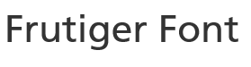

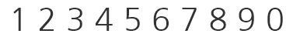

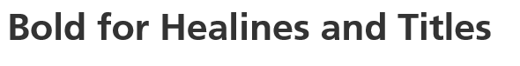
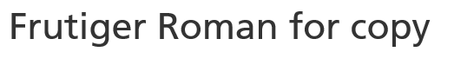

Logo
Our logo represents:

Our logo is important because it is the visual aspect of our brand and how students and community members will recognize us. We will use our logo on all club handouts, event poster and flyers and social media.

Tagline

Bridging the Gap One Hand at a Time.

Our tagline represents our brand through our mission statement. The bridging the gap is how we connect the community by educating Western and Bellingham about Hmong culture and bringing awareness to it. Also we are working toward bridging the gap between Hmong students and Universities by advocating to younger students about furthering their college education.

Colors

C: 86
M: 74
Y: 0
K: 0

C: 56
M: 0
Y: 100
K: 0

C: 5
M: 84
Y: 0
K: 0

